GPS - 300N
Item Check List
Please check all the following items have been included before starting.

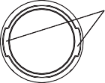
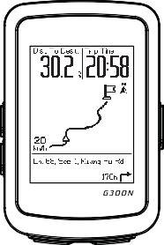
These two tendons must be on the left and right side of the bracket.
Rubber

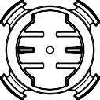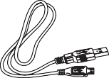

GPS - 300N
Bracket Micro USB Cable Rubber ties x4

How to mount the bracket
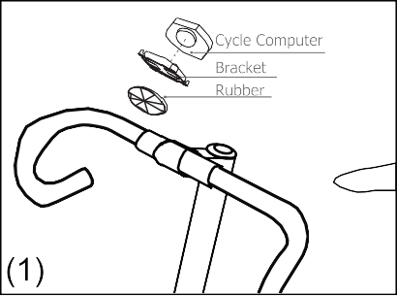
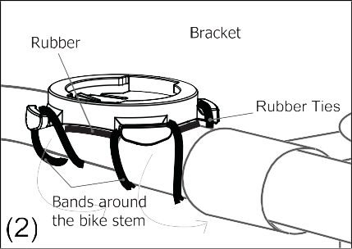
Use the rubber to tighten the bracket on the handlebar or stem with rubber ties.
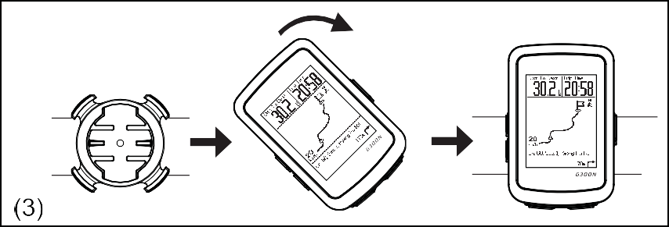

Place the GPS cycle computer on the bracket and secure it by turning clockwise.
The GPS computer main display and key function

Up Key

Down Key GPS Indicator

Pause / Return Key

Power Key / Backlight

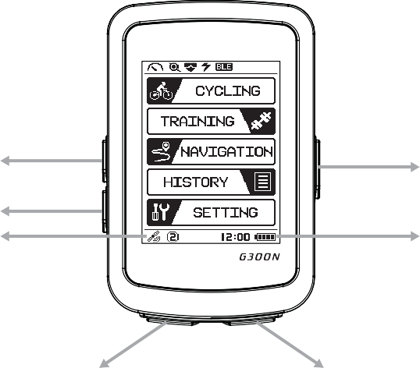
Battery Indicator

Record / Select Key

Turn on / off
To start the computer, hold the power key for 3 seconds until bee sound.

Auto Sleep

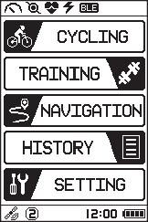
Auto sleep : When there is no recording after 6 minutes of no speed, and no button pressed the computer will turn off to save battery.
When there is recording after 1 hour with no speed, and no button pressed the computer will turn off to save battery.
Cycle
Press Up and Down Key to change mode.
Cycle Bike Page Cadence Page HR Page Power Page Total
NOTE: When the corresponding sensors are paired, the Cadence Mode, Heart Rate Mode, and Power Mode will appear.
The speed must maintain for 8 seconds or more to have AVG Cadence, AVG Heart Rate,

MAX Heart Rate %, and AVG Power data.
MAX
MAX
MAX

Training
Training FTP Test My Workout
Navigation
Navigation View Delete
View: Select track press up/down key to switch and press OK to view. Delete: Select track press up/down key to switch and press OK to delete.
History
History View Delete Delete All
Setting
Setting Profile Sensor Exercises General Altitude BLE Connect GPS System
Customized page
Setting Exercises User page Page Type
Press up/down key to select option
Contrast
Setting General System Contrast
Set Altitude
Setting Altitude Location sync.
Backlight
Short press on power button to turn ON/OFF backlight.
Set Sensor
Setting Sensor Choose Sensor Scan

Set Clock
Setting General System Clock
Clock will automatically adjust when GPS signal has been received.
Set Unit
Setting General System Unit
Set User
Setting Profile User Profile
Record
Under cycle mode press record.
MAINTENANCE
If the display contrast changes and figures become faint, it's time to recharge the battery. Do not expose cycle computer to extremely cold or hot temperatures i.e. don't leave the unit in direct sunlight for extended periods of the time.
TROUBLESHOOTING
Q1. Display is black or very light:
The battery power may be low. Recharge the battery. Q2. Display becomes dark or black:
The unit may be too hot. Place the unit in a shaded area, and it will return to normal. Q3. The unit operates slowly or struggled:
The unit is too cold. Warm the unit, and it will return to normal. Q4. Data in display varies enormously:
Check the surroundings for electromagnetic or away from the source of interference.
Q5. Data in display shows slowly:
The unit may be affected by low temperature factor, but it does not influence the function reading. When the temperature rises,
Q6. Current Speed does not appear:
It may cause by the following situation:
A. Speed from GPS: GPS signal is weak, please make sure turn on the GPS and move to the outdoor, a wide area without inter
B. Speed from the sensor: The distance & position too far, please refer to the sensor’s manual and adjust. Q7. Altitude seems not accurate:
The device altitude can be entered for more accurate data.
LIMITED WARRANTY
The product is for one-year limited warranty commencing on the date of purchase by the seller. The product will be free from defects in material and workmanship for one year from the date of manufacture.
Warranty does not cover damages due to misuse, abuse, or accidents, cracked or broken cases, negligence of precautions, improper maintenance, or commercial use. Warranty is void if the repairs are done by non-authorized service technician.
The warranties contained herein are expressly in lieu of any other warranties including implied warranty of merchantability and/or fitness for purpose. In no event shall manufacturer be liable for any damages, direct or incidental, consequential, or special, arising out of or related to the use of this manual or the product described herein.
During the warranty period (one year) the product will either be repaired or replaced without charge.
IMPORTANT HEALTH NOTICE
Please read over the following information before using the GPS computer.
Never use the GPS computer in combination with other medical / implanted electronic equipment and device (especially heart pacemakers, EKG equipment, TENS equipment, cardio-pulmonary machines, and pacemaker).
If you are severely ill or pregnant, please consult your doctor before using GPS computer.
Keep this device away from children.
As with most electronic receiving devices, there can sometimes be interference that causes inaccurate display readouts. Avoid using GPS computer near common sources of interference. These include high voltage power lines, air conditioning motor units, fluorescent lights, wristwatches, mobiles, and computer.

Pair to Smart Phone
- Download “Ride for Life” from Google play or APP Store.

- Open the APP

- Go into SETTING, then go to page that display BLE CONNECT, below ID will appear.

- On the smart phone look for the same ID number which shows on the computer.
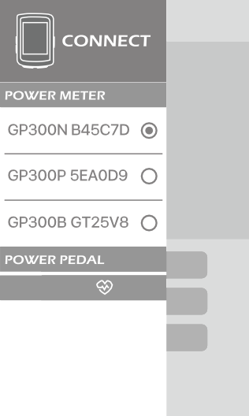
HEART RATE

- Press RECEIVE DATA, press the green RECEIVE DATA box again. Files will start receiving and a list of files which you had already record will be shown.
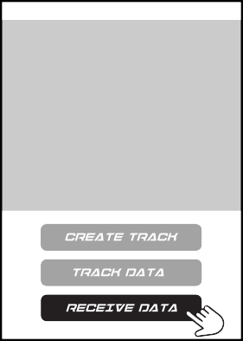
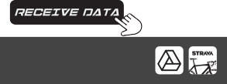
<<

- If you would like to upload the files to Strava, press the box of the file and press the Strava icon on the bottom right hand.
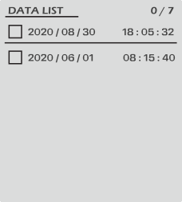
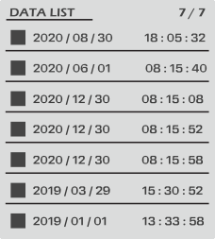
<<
<<
<<

- Log in to Strava first once all the steps are finish, there would be a little green check on the Strava icon, then press SEND. Upload will start and the data will be removed automatically after uploading.

SPECIFICATIONS

 | Computer
Operating temperature
Storage temperature
Weight | 65.2g
Size | 89mm x 59.2mm x 20.4mm
Battery | Rechargeable Battery
Durability(Without Backlight) | 20Hr
Water Proof | IPX6
Transmission | Bluetooth Low Energy

Time : 99 (hour): 59 (minute): 59 (Second)
Speed : 0〜99.9KM/0~62.4 Mile
Trip distance : 0~9999.99 KM / 0~6249.99 Mile
Odometer : 0~999999 KM/ 0~624999 Mile
Cadence : 0~999 RPM
Heart Rate : 30~240 BPM
Power : 0~999 WATT
Current Gradient : -99~99
AVG/MAX Gradient : 0~99
ALT Gain/ Loss : 0~30479 M/0~99999 FT
Total Altitude : 0~304799M/0~999999 FT
Maximum Altitude : 0~3999 M / 0~9999 FT
Current Altitude : -699~3999M /-999~9999FT
Wheel Size Chart

